Simple technique and characterization studies of spinel SrFe₂O₄ nanoparticles

G. Padmapriya
Department of Chemistry, Bharath Institute of Higher Education and Research,
Bharath University, Chennai – 600 073, Tamil Nadu, India

Abstract
Spinel SrFe₂O₄ nanoparticles were prepared effectively by simplistic, economical microwave heating method. The samples were successfully characterized by XRD pattern, EDX spectra, FT-IR analysis, HR-SEM analysis, and VSM instrumentation techniques. XRD, EDX and FT-IR results demonstrated that the products contain a pure single-phase spinel structure lacking of other secondary phase impurities. SEM results confirmed the spherical shaped nanoparticle morphology of the sample. Magnetic characterization property was confirmed by VSM analysis. VSM hysteresis loop established the superparamegnetism of the sample and the magnetization (M_{s}) value of SrFe₂O₄ is 0.153 emu/g.
Keywords: Spinel SrFe₂O₄; Nanocrystals; Magnetic property.

1. Introduction
In recent times, spinel transition semiconductor oxide nanomaterials have been broadly studied, due to their sole opto-electromagnetic and catalytic/photocatalytic properties than those of their bulkiness materials [1-3]. Commonly, spinel aluminates (A²⁺(Fe³⁺)₂O₄: A²⁺ = Zn²⁺, Sr²⁺, Cu²⁺) have develop into an significant materials, owing to their probable applications in different multidisciplinary areas [3-5]. Among various spinel SrFe₂O₄ has been investigated extensively [5]. Several techniques have been used to prepare the spinel type transition metal oxide semiconductor nanoparticles, for example solvothermal, co-precipitation, solvothermal, sol-gel and hydrothermal methods [6-10] etc. But, the above said methods meet several inconveniences for instance required long time procedures, high temperature and high-energy overriding, costly and complicated equipments and multifaceted procedures [11-16]. Amongst the above conservative methods, easy and cost proficient routes to prepare spinel metal oxide semiconductor nanoparticles by exploitation of inexpensive, cheap, low cost, non-toxic and environmentally benevolent precursors are unmoving key issues.

2. Experimental
2.1. Materials and methods
Strontium nitrate, copper nitrate as the raw materials were used. Millipore water was used for this synthesis. Nitrates of Strontium, and ferric nitrate were dissolved under stirring for 1 h and then located in a domestic microwave oven for 15 min, solid powders are formed, and then washed with water and ethanol and kept at 70 ºC for 1h.

2.2. Characterization
Structural formation of spinel SrFe₂O₄ nano-crystals were carry out using a Rigaku Ultima XRD (λ = 1.5418 Å). The corresponding metal-oxide group formation was analyzed by Perkin Elmer FT-IR spectra. Surface morphology was achieved with a Joel JSM 6360 HR-SEM analysis at desired magnification.

3. Results and discussion
3.1. Powder XRD analysis
Crystal nature, crystal formation, size and purity were established by analyzing the powder X- XRD pattern. Fig. 1 shows the XRD patterns of SrFe₂O₄ sample. The XRD diffraction peaks may possibly index single-phase spinel cubic structure of SrFe₂O₄.
Lattice parameter was designed using the given formula in Eq. (1):
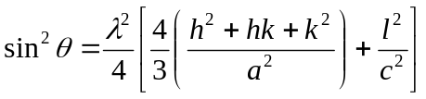 ---- (1)
where ‘θ’ is the diffraction angle, h, k, and l are Miller’s indices and ‘λ’ is the incident wavelength (λ = 0.1540 nm). The lattice parameter of SrFe₂O₄ sample is 8.055 Å [3].
The crystallite size of was designed by Scherrer formula given in Eq. (2):
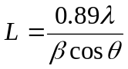 ------ (2)
where ‘L’ is the crystallite size, ‘θ’ is the Braggs angle diffraction, ‘λ’ is the X-ray wavelength (1.5406 Å) and ‘β’ is Full Width at Half Maximum (FWHM). The calculated crystallite size of spinel SrFe₂O₄ sample is 35.28 nm. Nevertheless, the microwave irradiation process, the microwave-oven has produced microwaves energy at a power of 850 W and converted into thermal energy, which resulting the functional nano-sized SrFe₂O₄ sample.

3.2. FT-IR spectroscopy
FT-IR spectra of spinel SrFe₂O₄ sample is given in Fig. 2. A wide-ranging vibration band at ~3425 cm⁻¹ to 3255 cm⁻¹ is connected with the OH vibration of water molecules, representing superior amount of exterior OH. In addition, two main wide M-O bands in the range of 420-900 cm⁻¹ indicate the spinel materials [3], which is spinel SrFe₂O₄ sample.

3.3. HR-SEM analysis
The surface morphology was analyzed by HR-SEM analysis and is exposed in Fig. 3. Fig. 3 shows the HR-SEM image of spinel SrFe₂O₄ sample exhibit homogeneous sphere-like nanoparticles. The smaller agglomerations of the products are mainly due to the influence of microwaves for the homogeneous distribution of the samples, which makes agglomeration and also magnetic relations between the resources.

3.4. EDX analysis
The elemental and sample purity was confirmed by EDX technique. Fig. 4 shows the EDX spectra of SrFe₂O₄ sample, which contains the peaks of Sr, Fe and O and the absence other secondary peak observation, confirmed the purity products.

3.5. VSM measurements
The magnetic assets of the spinel SrFe₂O₄ sample was analysed by VSM at field ranging upto ± 10 kOe is exposed in Fig. 5. VSM hysteresis (M-H) loop confirmed superparamagnetism. The saturation magnetization (M_{s}) value was obtained to be 0.125 emu/g. From the VSM results, it was inference the magnetic property of the products depending on their size, and shape of the nanopowders.

4. Conclusions
Spinel SrFe₂O₄ sample was synthesized successfully by a facile microwave heating rout. XRD, EDX and FT-IR results specified that the prepared spinel SrFe₂O₄ sample have spinel structure with well crystalline product and also free from other phase impurities. The HR-SEM result revealed that spinel SrFe₂O₄ sample contain nanoparticle-like morphology. The specific M_{s} values were obtained to be 0.125 emu/g for spinel SrFe₂O₄ sample.

References
- A. Manikandan, M. Durka, K. Seevakan, S. Arul Antony, Journal of Superconductivity and Novel Magnetism, 28 (2015) 1405-1416.
- A. Manikandan, M. Durka, S. Arul Antony, Journal of Superconductivity and Novel Magnetism, 28 (2015) 209–218.
- A. Manikandan, M. Durka, S. Arul Antony, Journal of Inorganic and Organometallic Polymers and Materials, 25 (2015) 1019–1031.
- A. Manikandan, M. Durka, S. Arul Antony, Journal of Superconductivity and Novel Magnetism, 27 (2014) 2841–2857.
- A. Manikandan, S. Arul Antony, R. Sridhar, M. Bououdina, Journal of Nanoscience and Nanotechnology, 15 (2015) 4948-4960.
- A. Manikandan, M. Durka, S. Arul Antony, Advanced Science, Engineering and Medicine, 7 (2015) 33-46.
- A. Manikandan, E. Hema, M. Durka, K. Seevakan, T. Alagesan, S. Arul Antony, Journal of Superconductivity and Novel Magnetism, 28 (2015) 1783-1795.
- A. Manikandan, M. Durka, S. Arul Antony, Journal of Superconductivity and Novel Magnetism,
28 (2015) 2047–2058.
- K. Chinnaraj, A. Manikandan, P. Ramu, S. Arul Antony, P. Neeraja, Journal of Superconductivity and Novel Magnetism, 28 (2015) 179-190.
- M. F. Valan, A. Manikandan, S. Arul Antony, Journal of Nanoscience and Nanotechnology, 15 (2015) 4543-4551.
- E. Hema, A. Manikandan, S. Suganya, M. Durka, S. Arul Antony, B. R. Venkatraman,
Journal of Superconductivity and Novel Magnetism, 28, 8 (2015) 2539-2552
- S. Jayasree, A. Manikandan, A. M. Uduman Mohideen, C. Barathiraja, E. Hema, S. Arul Antony, Advanced Science, Engineering and Medicine, 7, (2015) 672-682.
- A. Mary Jacintha, A. Manikandan, K. Chinnaraj, S. Arul Antony, P. Neeraja, Journal of Nanoscience and Nanotechnology, 15, 9732-9740 (2015)
- A. Manikandan, M. Durka, M. Autha Selvi, S. Arul Antony, Journal of Nanoscience and Nanotechnology, 16 (2016) 448-456
- A. Manikandan, R. Sridhar, S. Arul Antony, S. Ramakrishna, Journal of Molecular Structure, 1076 (2014) 188-200.
- A. Manikandan, M. Durka, M. Amuth Selvi, S. Arul Antony, Journal of Nanoscience and Nanotechnology, 16 (2016) 357-373

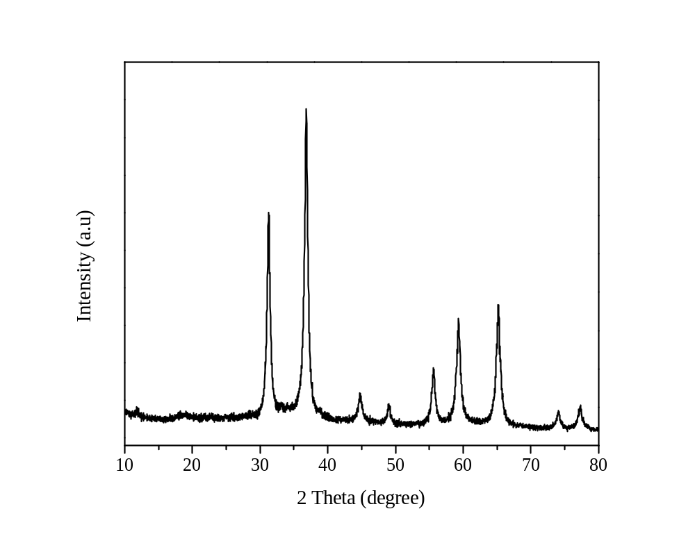

Figure 1. Powder XRD pattern of spinel SrFe₂O₄ sample.

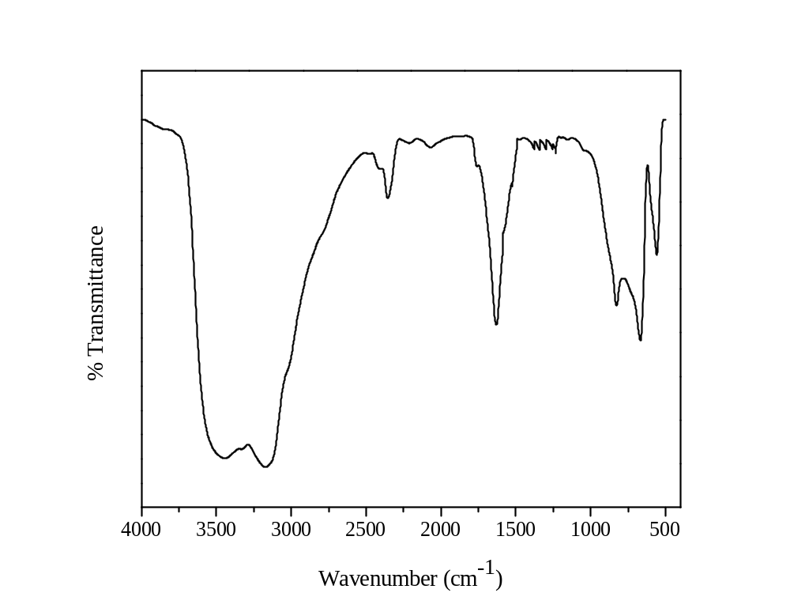

Figure 2. FT-IR spectra of spinel SrFe₂O₄ sample.

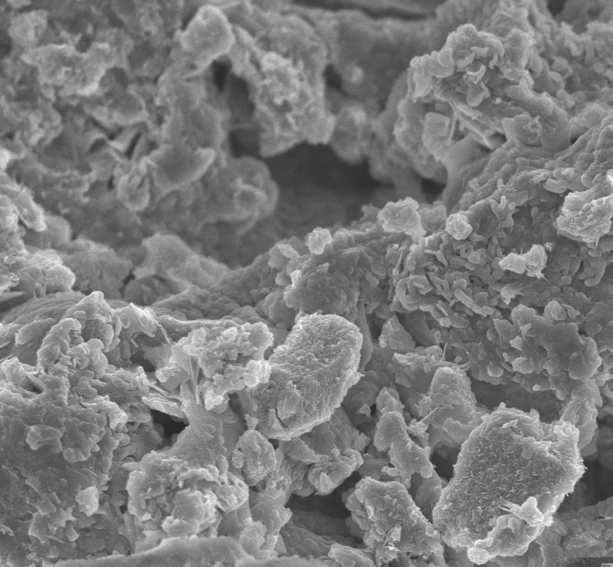
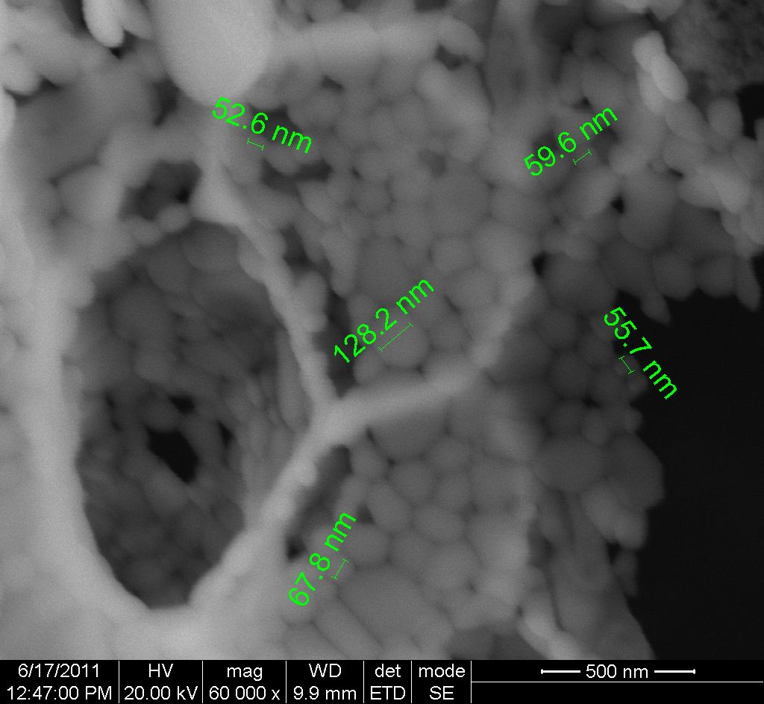

Figure 3. HR-SEM image of spinel SrFe₂O₄ sample.

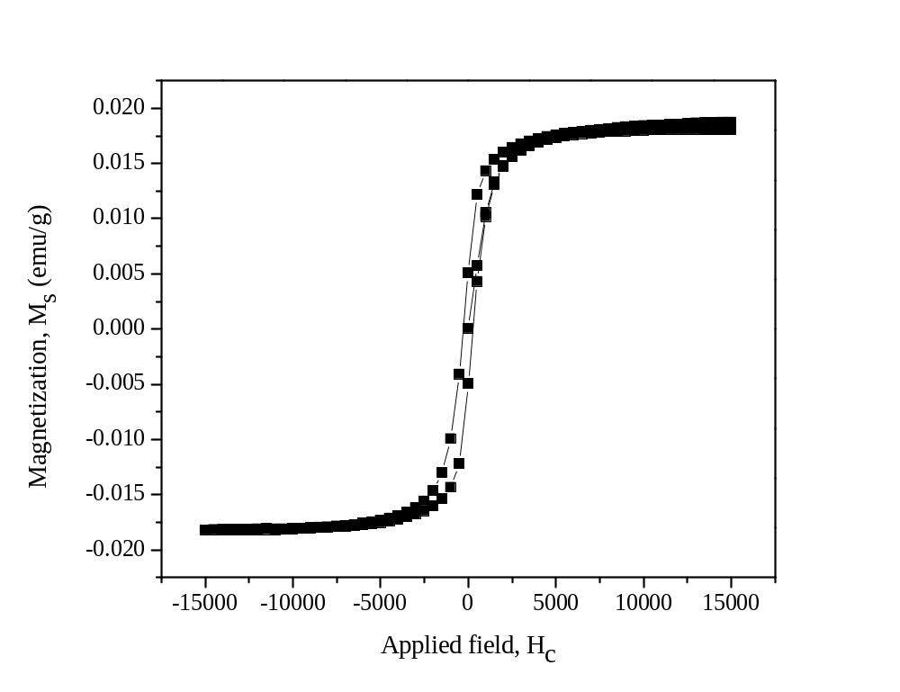

Figure 4. Magnetic (M-H) hysteresis loop of spinel SrFe₂O₄ sample.

